THE NORTHEN EDUCATION DIVISION
MALAWI SCHOOL CERTIFICATE OF EDUCATION MOCK EXAMINATION
2026 AGRICULTURE
PAPER I
(100 MARKS)

1(a). Mention any two activities involved in processing maize.
- dehusking
- Shelling
- Drying
- Milling/grinding
- Cleaning
- Sieving
- Boiling/cooking
(One mark for each point)
(b). State any two aims of crop improvement.
- Improve ability of plants to divert the biomass to harvestable portions
- Develop crops that are resistant to pests and diseases
- Improve quality of crops
- Develop crops that can withstand poor environmental conditions
- Develop early maturing crops
- Produce crops that are easy to store
- To increase quantity of crop yields
- Improve quality of raw materials
(One mark for each point)

(c). Explain any two disadvantages of vegetative propagation
- Vegetative planting materials cannot be stored for a long time¹/ since they wilt and die¹
- They are bulky therefore difficult to transport¹ and prepare them for planting¹
- There is high risk of transmitting diseases¹ from the parent to the new plants¹
- Difficult to introduce crop variation¹ hence crop improvement becomes difficult¹
- Plant materials need to be handled with care¹ otherwise can be destroyed¹
(One mark for each point, one mark for explanation)

(d). State any factors that affect soil depth
- Slope of land
- Parent material/parent materials resistant to erosion form deeper soils
- Age of the soil
(One mark for each point)
2.a controlling stocking rates
- Matching grazing to pasture carrying capacity
- Providing sufficient grazing intervals/resting periods
(One mark for each point)
(b). Importance of Food fortification
- Adds critical nutrients to everyday foods¹ hence improving the peoples immune system against diseases¹
- A low cost way of supplying nutrients to the vulnerable¹ using the existing food systems¹
- Does not require dietary changes¹ as it uses the foods that people eat regularly¹
- Delivers proven health and economic benefits¹ through breaking malnutrition and poverty leading to long term economic stability¹
(One mark for each point, one mark for explanation)

c). Outline any two disadvantages of hybridisation in agriculture.
- Farmers become dependent on seed companies hence lose resilient local varieties and face higher costs
- Influx of commercial hybrids that require specific fertilisers, pesticides and seeds annually
- It is labour demanding
- Offsprings may not inherit desired qualities
- Can displace traditional locally adapted crops
- May inherit genetic disorders from both parents
- Can threaten endangered species endanger
(One mark for each point)

3 .a. State any two forms of mixed cropping
- In-breeding
- Cross breeding
- Out breeding
(One mark for each point)
(b). Importance of steaming up in nannies.
- Gives sufficient nutrients to the rapidly growing foetus
- Gives nannies enough energy for parturition
- Provides sufficient nutrients to nannies for production of milk
(One mark for each point, one mark for explanation)

(c).
- Planting trees and grasses¹ – Trees and grasses reduce the speed of water –runoff¹
- Practising crop rotation¹ – Alternating closely growing crops and sparsely growing crops, as closely growing crops offer protection on the soil¹
- Mulching¹- Reduces speed of water runoff¹/ Provide soil protection from raindrop impact¹
- Manure application¹ -Maintains soil structure and add soil nutrients¹
(One mark for each point, one mark for explanation)
(d). feed ration is the specific daily allowance of feed given to an animal (one mark for definition)

- (a). Biogas production
(b).
- prevents direct methane emissions into the atmosphere¹/methane has more potential at warming the earth than¹
- Displaces use of fossil fuels¹/ as it is used as a source of clean energy for cooking and heating¹
- Solid and liquid by-product is used as manure (biofertilisers)¹/reducing the need for synthentic fertilisers¹
- Improves waste management¹/provide sanitary methods for treating organic waste from farms thereby reducing pollution¹
- Figure 1 is a diagram showing a source of farm power. Use it to answer the questions that follow.
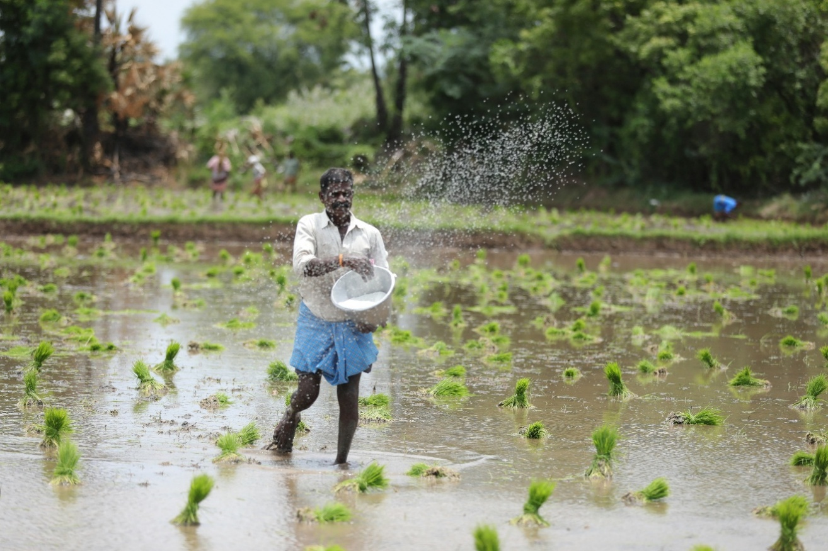

- Identify the source of farm power
Human power¹
(1 mark)
- Explain any two ways of improving the workforce for the farm power in 5(a)
- Improving health of people¹/ensuring they are strong enough for the work¹
- Train the work force¹/to improve their skills¹
- Proper feeding¹/as food is a source of energy in carrying farm operations¹
- Motivate workers with good working conditions¹/ so that they can be willing to work¹
- Assign duties according to expertise¹/ in order to not to burden the workforce¹
- Provide them with efficient tools¹/ to carry out operations smoothly¹
- Promoting team work and cooperation¹/to minimise conflicts¹
- Ensuring rules and regulations are clearly stated¹/ to guide workers in the course of their work¹
- provide efficient supervisors¹/ to ensure quality work¹
(4 marks for any two)
- Explain any two effects of gender biases in agricultural technology
- Food insecurity due to low yields/due to low yields as a result of not using technologies
- Increased poverty due to low income level as farmers cannot afford basic needs
- Low rate of national development/ due to low farm output hence government cannot collect enough taxes
- Low farmers income/due to reduced production which reduces surplus for sale
- Low agricultural production/most females perform farm operations manually delaying operations
( 4 marks for any two)
6.a). Describe any one factor that affects the rate at which animals reach puberty.

- Breed of the animal¹. Exotic breeds reach puberty stage much earlier than indigenous breeds¹
- Nutrition¹. Animals that are well fed reach puberty much earlier since they get enough nutrients for growth¹.
- Exposure to opposite sex¹. Heifers that are kept together with bulls reach puberty earlier¹.
- Animal type¹. Dairy cattle reach puberty much earlier than beef cattle1¹.

(2 marks for any one)

(b). K340 000 + K40 000= K380 000 (1 mark)
$=\frac{K380 000}{K5000}X1 kg$ (1 mark)
= 76 kg (1 mark)
7a). Explain two ways farmers deal with risks and uncertainties in agricultural production.
  - Practicing mixed farming and mixed cropping. A farmer would have something to depend on in times of crop failure.
  - Insuring enterprises. A farmer is compensated for any risk and eventuality that may occur on the farm
  - Having sound net capital. Used as a caution in times of price fluctuation.
  - Guarding against theft and vandalism. This helps to prevent of loss of produce to theft.
  - Input rationing to prevent wastage of production resources.
  - Contract farming to deal with price fluctuation.
  - Crop rotation helps a farmer to have something to depend in times of crop failure.
(b) (i)Identify the parasite
Tape worm (1 mark)
(ii) Mention any one way in which the parasite affects the livestock.
- Suck digested feed from the animal’s intestines
- Cause wounds and suck blood from the animals’ intestines leading to anaemia
(1mark)
(iii) Give any one way of controlling the parasite
- Drenching with suitable drugs
- Practising controlled grazing (1mark)

8. (a) define progeny testing
Progeny testing is the selection of male animals based on the performance of their offsprings
(b). (i). live stock with the reproductive system
- chicken,
- duck
(ii) functions of part labeled C
- forms muscular exit for the egg
- helps in expulsion of the egg
- Seals pores in the egg
(c). State any two situations that require a complete budget on the farm
- When proposed changes are major/big
- When farmers want to overhaul the whole farm
- When planning for a new farm ( 2 marks for any two )
9.(a) Give any one ways in which inoculation of pasture seed is important.
- To encourage nodule formation/ hence promoting nitrogen fixation. (
b(i). What type of marketing channel is presented in the table?
- Indirect marketing channel/4-tier marketing channel (1 mark)

ii. Calculate the marketing costs for Retailer (2 marks)
MK5000 + MK5000 + MK20000¹
= MK30000¹
iii. Calculate total marketing margin for the whole marketing channel. (2 marks)
Marketing Margin = Retailer Price – Farm Gate Price
= MK77000 – MK10000 ¹
= MK67000¹
10 a. What planting materials are used to propagate following plants asexually?

i) Ginger
Rhizome (1 mark)
(ii) sisal
Suckers (1 mark)

(b). Give any two risks and uncertainties currently affecting maize farmers in Malawi.

- Pests and diseases
- Hailstorms
- Theft
- Vandalism
- Drought
- Price fluctuation
- Lack of inputs
- Floods
- Lack of markets

SECTION B (30 MARKS)
Answer all questions in an essay form
11. Explain any five factors to consider when selecting livestock for breeding.
- Fast growth / so that they can reach mature weight fast hence saving feeding costs
- Mild Temperament/docile animals are easy to handle
- Good mothering ability/so that they can protect their young ones from danger
- High fertility rates/animals can breed regularly and have shorter calving intervals to produce more offsprings
- High survival rates/should have low mortality rates to increase livestock numbers
- Good health/to prevent death of animals
- Adaptation to the environment/animals that can adapt easily to harsh conditions and survive
- Body conformation/animals should be well shaped for a purpose like large udder for milk
(One mark for each point, one mark for explanation)

12. Explain any five ways in which agroforestry deals with climate change.
- Reduces soil erosion¹-Since trees reduces the speed of water runoff¹
- Improves soil fertility¹ since leguminous trees fix nitrogen in the soil¹
- Provide medicinal products. Parts of plants such as leaves and fruits are used to treat diseases¹.
- Provide shade¹ protecting crops, livestock from excessive temperatures¹
- Trees are used as feed for livestock¹. Plant leaves are used as fodder for animals¹
- Helps to increase crop yields¹ as decomposed tree leaves add nutrients to soil for crop use¹.
(One mark for each point, one mark for explanation)

13. Describe any five effects of population distribution on marketing of tomatoes.
- Influences the direction of flow of tomatoes¹. Tomatoes will be taken to areas with large populations since the offer attractive markets due to high demands¹
- Affects the length of marketing channel of tomatoes¹. High populated areas have long marketing channels because there are many agencies¹
- It affects quality of tomatoes sold¹. Tomatoes sold in high populated areas are of good quality due to competition among traders¹
- Affects the mode of transport used to take tomatoes to the market¹. In small populations agents use headloads, wheelbarrows because the loads are small and more advanced mode of transport are used in highly populated areas
- It determines the prices of tomatoes. Areas with low population density experience low prices due to low demand
- It affects the quantity of tomatoes required. More tomatoes will be taken to areas with high population due to high demand
- Affects the choice of people to target¹. Tomatoes promotion depend on age, income educational level in order to get maximum sales¹
- Affects the types of advertising methods used. Mass media/trade fares/exhibition/agricultural shows are highly common in highly populated areas since it is easier to reach many consumers at once

(One mark for each point, one mark for explanation)

